icanews

Frequently Asked Questions

What is a newsgroup?
It’s an Internet community which is dedicated to a particular topic of interest - a sort of electronic notice board.

icanews is a closed group, which means it is only available to approved members by invitation.

How does it work?
A message, or ‘post’, on a newsgroup may be a response to a previous post or be a new post. Members can reply to any post and a discussion or ‘topic’ is formed. All subscribers can post and read messages.

How do I subscribe?
You need to be a member of ICA and to agree to the newsgroup conditions. You will then receive an invitation to sign up before you can start using icanews.

We are able to keep our costs to a minimum by using icanews for all communication with members, including information about seminars and training, so it’s important to sign up straight away so you can enjoy all the benefits of ICA membership.

How do I post a message?
Posting a message is like sending any email. Our newsgroup’s email address is: icanews@groups.io so just type this in the TO box, enter the SUBJECT, then type your comment or questions and hit SEND.

If you want to respond to a newsgroup message, just click on the message heading to open it, then scroll to the bottom and click on reply.

Take care, within minutes your reply will appear on the newsgroup - for everyone to read.

That's why we need newsgroup etiquette (see below).
You may prefer to reply directly to the sender without your message going back to the whole group. You can do this from the DIRECTORY. In the navigation panel on the left click on DIRECTORY, you can then send an email directly to another member by clicking their Email button next to their entry. (This feature is limited to two emails per day to the same person).
Note: You may need to change your own profile setting before you can see the directory because only members who have chosen to make their profile visible can see other members who have opted to be included in the directory.
If you need any help with this contact Jacqui on membership@icanet.org.uk

Who uses the newsgroup?
Most members are consumer specialists, based in Trading Standards, Citizens Advice and other advice services, but not exclusively. Members also come from many other consumer related organisations, including business, government departments, NGOs, universities and other like-minded organisations.
This makes icanews one of the most knowledgeable, helpful and practical consumer advice resources available today - allowing you to tap into the combined knowledge and expertise of ICA members.
What about confidentiality?
The icanews newsgroup is restricted to named members and circulation of newsgroup messages to any other party is forbidden.

Members pay for icanews through their membership subscriptions, so copying information to colleagues is not just unfair to all the members who are paying for it, it's also a breach of the newsgroup conditions. We can't prevent people from forwarding newsgroup information, but misuse will result in automatic removal from the newsgroup.
If you are seeking information for a third party, you must make it clear when you request the information, so that other members can decide how to respond.
When discussing cases, you may find it easier to attach copy contracts or correspondence but before posting you must remove consumer’s names and those of traders, or any details by which they could be identified.
What sort of thing, can I use the newsgroup for?

You can:

- Request advice or information on a case you are dealing with

- Pose questions on issues and cases

- Seek or provide information on current, new and proposed consumer legislation

Give or ask for information on failed businesses, scams, rogue traders, home authorities, etc.

- Discuss issues like best practice, case law, government policy and consultations – any consumer related subject.

- Let other members know what’s happening in your area.

What can't I post on the newsgroup?
The group is not to be used for any unauthorised commercial activity. For example, if you want to advertise a vacancy or any other commercial editorial, there may be a charge. For details, contact Jacqui King on: membership@icanet.org.uk

If you post a commercial message, without authority, ICA will automatically invoice you.

....and obviously, it's not the right place to share your personal information, photographs or jokes. If that's what you want, join Facebook!

Can I have my newsgroup messages, all in one place?
You can choose how you receive your messages. Most members like to have individual messages as soon as they are posted but you can choose a daily summary or to receive messages in batches of 12. Click on SUBSCRIPTION in the navigation panel on the left to see the options.

From this page, you can also add a signature. For example, you may want to include your contact details in each email, to make it easier for people to respond to only you.

Remember to scroll to the bottom of the page and click SAVE once you have made your changes.

Who can I contact if I need help?
icanews is managed by moderators. If you have a question about your membership or subscription, or need any other information about using the newsgroup, contact Jacqui on: membership@icanet.org.uk. You can also contact Jemma on: socialmedia@icanet.org.uk for information about the newsgroup or our ICA Twitter account.

There’s also a comprehensive help section on the newsgroup. If you’d like to explore and use some of the features – click on HELP and then have a look at the Members Manual or FAQs.

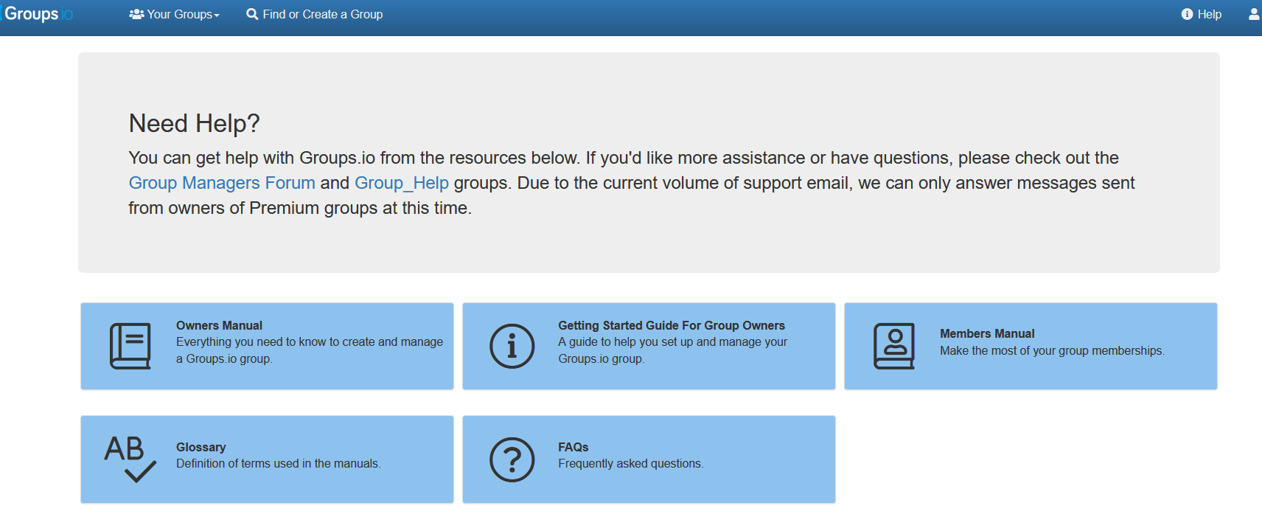
What if I change my email address?
You will stop receiving or being able to send messages until you change your email address on the newsgroup. Just let Jacqui know your new email address and she’ll update the membership database and send you an invitation to amend your newsgroup connection.

You can only send or receive messages using the same email address you used to join icanews. If you try using a different one, the newsgroup won’t recognise you. However, you can use more than one email address as long as you sign up with each of the email addresses you want to use.

What is newsgroup etiquette?
It's really just about good manners and consideration for other subscribers. A newsgroup is only successful if all subscribers respect other users by:

- not blocking inboxes unnecessarily
- treating all messages as confidential
- including your own contact details in case people want to reply to you personally
- never forgetting that your messages go to everyone - so think before hitting REPLY

To protect both our members and the integrity of the group, all members are required to read and adhere to the newsgroup conditions and guidance on good practice. All new members are sent the conditions when they join ICA but if you would like another copy, email membership@icanet.org.uk.

Finally, our members say that the best thing about ICA membership is being able to ask everyone else for help – and get answers. So, don’t be afraid to ask a question or to respond to one if you can help your colleagues with an answer, or just have some useful information to share.

